Chris Carrier WD 220

10/27/13 Chapter 6

6-1

<!DOCTYPE html PUBLIC "-//W3C//DTD XHTML 1.0 Strict//EN"

"http://www.w3.org/TR/xhtml1/DTD/xhtml1-strict.dtd">

<html xmlns="http://www.w3.org/1999/xhtml">

<head>

<title>Song Organizer</title>

<meta http-equiv="content-type" content="text/html; charset=iso-8859-1" />

</head>

<body>

<h1>Song Organizer</h1>

<?php

if(isset($_GET['action'])){

if((file_exists("SongOrganizer/songs.txt"))

&& (file_size("SongOrganizer/songs.txt") != 0)){

$SongArray = file("SongOrganizer/songs.txt");

switch($_GET['action']){

case 'Remove Duplicates':

$SongArray = array_unique($SongArray);

$SongArray = array_values($SongArray);

break;

case 'Sort Ascending':

sort($SongArray);

break;

case 'Shuffle':

shuffle($SongArray);

break;

} // End of the switch statement

if(count($SongArray)>0){

$NewSongs = implode($SongArray);

$SongStore = fopen("SongOrganizer/songs.txt", "wb");

if($SongStore === false)

echo "there was an error updating the song file \n";

else{

fwrite($SongStore, $NewSongs);

fclose($SongStore);

}

}

else

unlink("SongOrganizer/songs.txt");

}

}

if(isset($_POST['submit'])){

$SongToAdd = stripslashes($_POST['SongName']) . "\n";

$ExistingSongs = array();

if(file_exists("SongOrganizer/songs.txt") && filesize("SongOrganizer/songs.txt") > 0){

$ExistingSongs = file("SongOrganizer/songs.txt");

if(in_array($SongtoAdd, $ExistingSongs)){

echo "<p>The song you entered already exists!<br />\n";

echo "Your song was not added to the list.</p>";

}

else{

$SongFile = fopen("SongOrganizer/songs.txt", "ab");

if($SongFile === false)

echo "There was an error saving your message!\n";

else{

fwrite($SongFile, $SongToAdd);

fclose($SongFile);

echo "Your song has been added to the list.\n";

}

}

}

}

if((!file_exists("SongOrganizer/songs.txt")) || (filesize("SongOrganizer/songs.txt") == 0)){

echo "<p>There are no songs in the list.</p>\n";

}

else{

$SongArray = file("SongOrganizer/songs.txt");

echo "<table border=\"1\" width=\"100%\" style=\"background-color:lightgray\">\n";

foreach($SongArray as $Song){

echo "<tr>\n";

echo "<td>" . htmlentities($Song) . "</td>";

echo "</tr>\n";

}

echo "</table>\n";

}

?>

<p>

<a href="SongOrganizer.php?action=Sort%20Ascending">Sort Song List</a><br />

<a href="SongOrganizer.php?action=Remove%20Duplicates">Remove Duplicates Songs</a><br />

<a href="SongOrganizer.php?action=Shuffle">Randomize Song List</a><br />

</p>

<form action="SongOrganizer.php" method="post">

<p>Add New Song</p>

<p>Song Name: <input type="text" name="SongName" /></p>

<p><input type="submit" name="submit" value="Add Song to List" />

<input type="reset" name="reset" value="Reset Song Name" /></p>

</form>

</body>

</html>

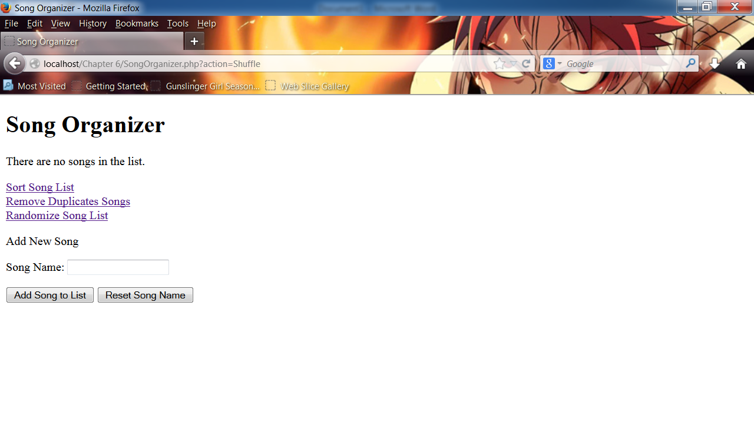

6-2

<!DOCTYPE html PUBLIC "-//W3C//DTD XHTML 1.0 Strict//EN"

"http://www.w3.org/TR/xhtml1/DTD/xhtml1-strict.dtd">

<html xmlns="http://www.w3.org/1999/xhtml">

<head>

<title>Box Array</title>

<meta http-equiv="content-type" content="text/html; charset=iso-8859-1" />

</head>

<body>

<?php

//Box Array

$SmallBox = array("length" => 12, "width" => 10, "depth" => 2.5); // Length

$MediumBox = array("length" => 30, "width" => 20, "depth" => 4); // Width

$LargeBox = array("length" => 60, "width" => 40, "depth" => 11.5); // Depth

// Box Conversion

$VolumeConversion = array("SmallBox" => $SmallBox, "MediumBox" => $MediumBox,

"LargeBox" => $LargeBox);

//Volume Conversion

$Volume["Volume"] = $VolumeConversion;

//Small Box

echo "<p>The Volume of the Small Box is (" . $Volume['Volume']['SmallBox']['length']

. " * " . $Volume['Volume']['SmallBox']['width'] . " * " . $Volume['Volume']['SmallBox']['depth'] . ").\n";

//Medium Box

echo "<p>The Volume of the Medium Box is (" . $Volume['Volume']['MediumBox']['length'] . " * " .

$Volume['Volume']['MediumBox']['width'] . " * " . $Volume['Volume']['MediumBox']['depth'] . ").\n";

//Large Box

echo "<p>The Volume of the Large Box is (" . $Volume['Volume']['LargeBox']['length'] . " * " .

$Volume['Volume']['LargeBox']['width'] . " * " . $Volume['Volume']['LargeBox']['depth'] . ").</p>";

?>

</body>

</html>

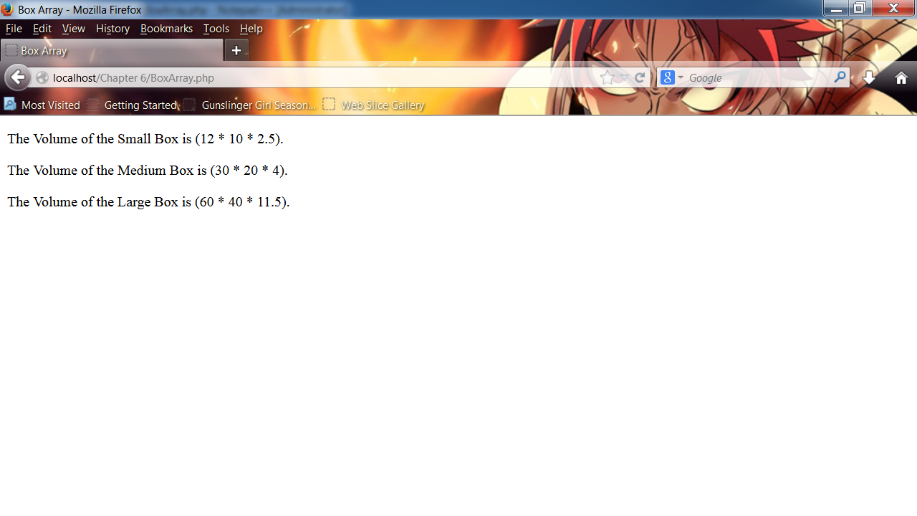

6-4

<!DOCTYPE html PUBLIC "-//W3C//DTD XHTML 1.0 Strict//EN"

"http://www.w3.org/TR/xhtml1/DTD/xhtml1-strict.dtd">

<html xmlns="http://www.w3.org/1999/xhtml">

<head>

<title>Sign Guest Book</title>

<meta http-equiv="content-type" content="text/html; charset=iso-8859-1" />

</head>

<body>

<?php

if(isset($_POST['submit'])){

$GuestToAdd = stripslashes($_POST['guestname']) . "\n";

$EmailToAdd = stripslashes($_POST['email']) . "\n";

$ExistingGuest = array();

if(file_exists("guestbook.txt") && filesize("guestbook.txt") > 0){

$ExistingGuest = file("guestbook.txt");

}

if(in_array($GuestToAdd, $ExistingGuest)){

echo "<p>The information you entered already exists!<br />\n";

echo "Your information was not added to the list.<br />\n";

echo "Your information was not saved.</p>";

$GuestToAdd = "";

$EmailToAdd = "";

}

else{

$GuestFile = fopen("guestbook.txt", "ab");

if($GuestFile === false)

echo "There was an error saving your information!\n";

else{

fwrite($GuestFile, $GuestToAdd, $EmailToAdd);

fclose($GuestFile);

echo "Your name has been added to the list.\n";

$GuestToAdd = "";

$EmailToAdd = "";

}

}

}

if(empty($_POST['guestname']) || empty($_POST['email'])){

echo "<p>You must enter the guest name and email correctly. Click your browser's Back button

to return to the Guest Book.</p>\n";

}

else{

$Name = stripslashes($_POST['guestname']);

$Email = stripslashes($_POST['email']);

//Validate Email

echo "The email address &ldquo;" . $Email . "&rdquo; ";

if(preg_match("/^(([A-Za-z]+\d+)|" . "([A-Za-z]+\.[A-Za-z]+))" .

"@[_a-z0-9-]+(\.[a-z0-9-]+)*(\.[a-z]{2,})$/i", $Email) == 1){

echo " is a valid email address. <br />";

}

else{

echo " is not a valid e-mail address. <br />";

}

$GuestFile = fopen("guestbook.txt", "ab");

if(is_writeable("guestbook.txt")){

if(fwrite($GuestFile, $Name . ", " . $Email . "\n"))

echo "<p>Thank you for signing our guest book!</p>\n";

else

echo "<p>Cannot add your name to the guest book.</p>\n";

}

else

echo "<p>Cannot write to the file.</p>\n";

fclose($GuestFile);

}

if(isset($_GET['action'])){

if((file_exists("guestbook.txt"))

&& (filesize("guestbook.txt") != 0)){

$GuestArray = file("guestbook.txt");

//Switch Statement

switch($_GET['action']){

case 'Remove Duplicates':

$GuestArray = array_unique($GuestArray);

$GuestArray = array_values($GuestArray);

break;

case 'Sort Ascending':

sort($GuestArray);

break;

/*case 'Shuffle':

shuffle($SongArray);

break;*/

} // End of the switch statement

if(count($GuestArray)>0){

$NewGuest = implode($GuestArray);

$GuestStore = fopen("guestbook.txt", "wb");

if($GuestStore === false)

echo "there was an error updating the guestbook file \n";

else{

fwrite($GuestStore, $NewGuest);

fclose($GuestStore);

}

}

else

unlink("guestbook.txt");

}

}

?>

</body>

</html>

<!DOCTYPE html PUBLIC "-//W3C//DTD XHTML 1.0 Strict//EN"

"http://www.w3.org/TR/xhtml1/DTD/xhtml1-strict.dtd">

<html xmlns="http://www.w3.org/1999/xhtml">

<head>

<title>Guest Book</title>

<meta http-equiv="content-type" content="text/html; charset=iso-8859-1" />

</head>

<body>

<h2>Enter your name and email address to sign in to our guest book</h2>

<form method="POST" action="SignGuestBook.php">

<p>Add New Guest</p>

<p>Name <input type="text" name="guestname" /></p>

<p>Email <input type="text" name="email" /></p>

<p><input type="submit" value="submit" /></p>

</form>

<p>

<a href="SignGuestBook.php?action=Sort%20Ascending">Sort Guest List</a><br />

<a href="SignGuestBook.php?action=Remove%20Duplicates">Remove Duplicates Information</a><br />

<a href="ShowGuestBook.php">Show Guest Book</a>

</p>

<?php

?>

</body>

</html>

<!DOCTYPE html PUBLIC "-//W3C//DTD XHTML 1.0 Strict//EN"

"http://www.w3.org/TR/xhtml1/DTD/xhtml1-strict.dtd">

<html xmlns="http://www.w3.org/1999/xhtml">

<head>

<title>Show Guest Book</title>

<meta http-equiv="content-type" content="text/html; charset=iso-8859-1" />

</head>

<body>

<?php

echo "<h2>Guest Book</h2>";

echo "<hr />";

echo "<pre>\n";

readfile("guestbook.txt");

echo "</pre>\n";

echo "<hr />\n";

?>

</body>

</html>

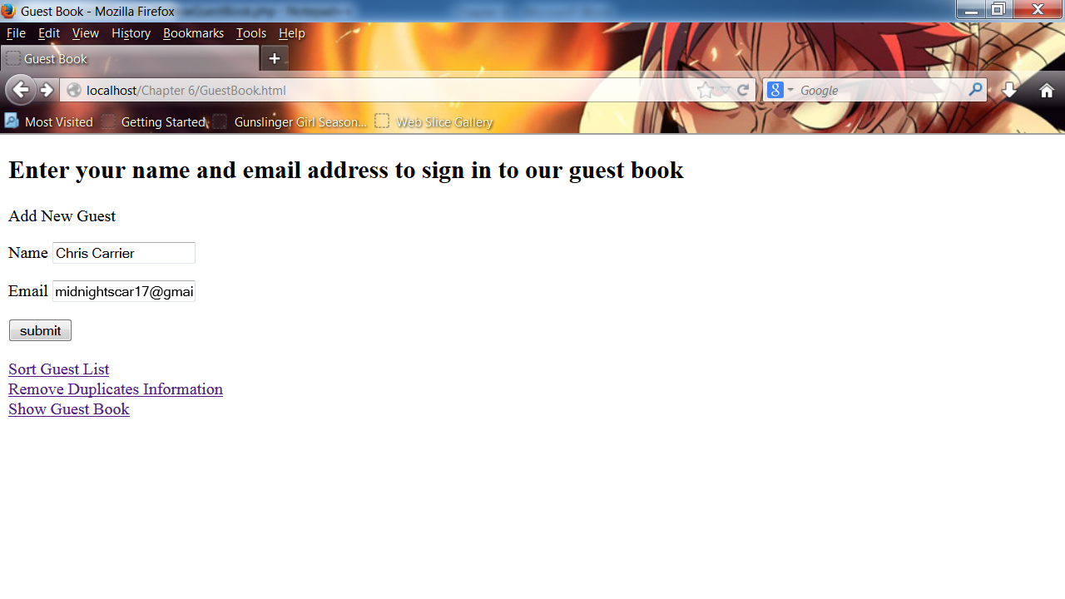

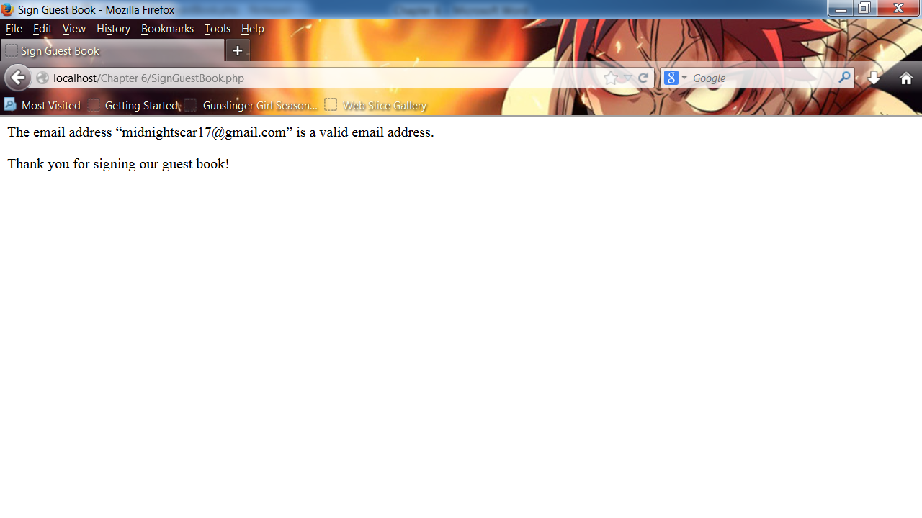

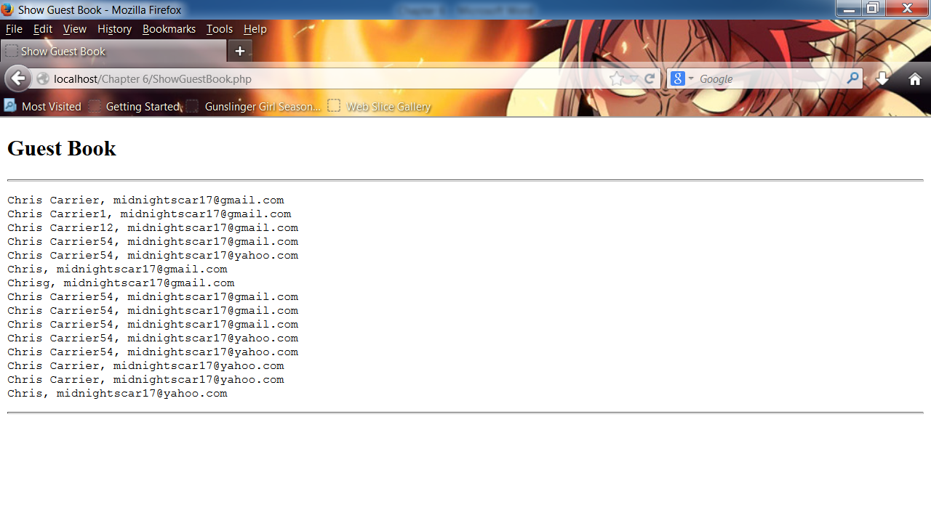

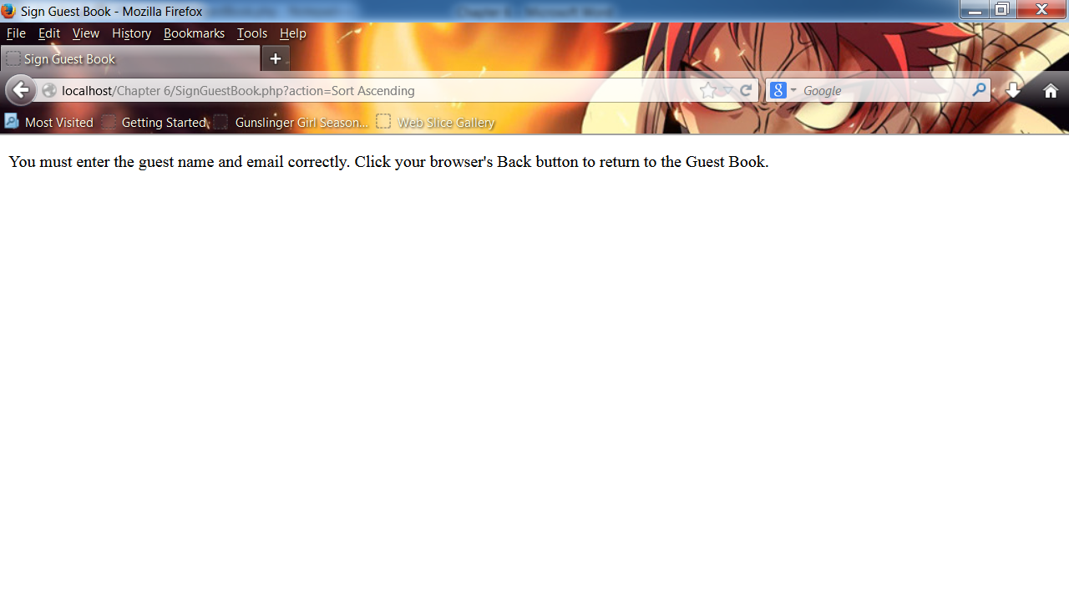

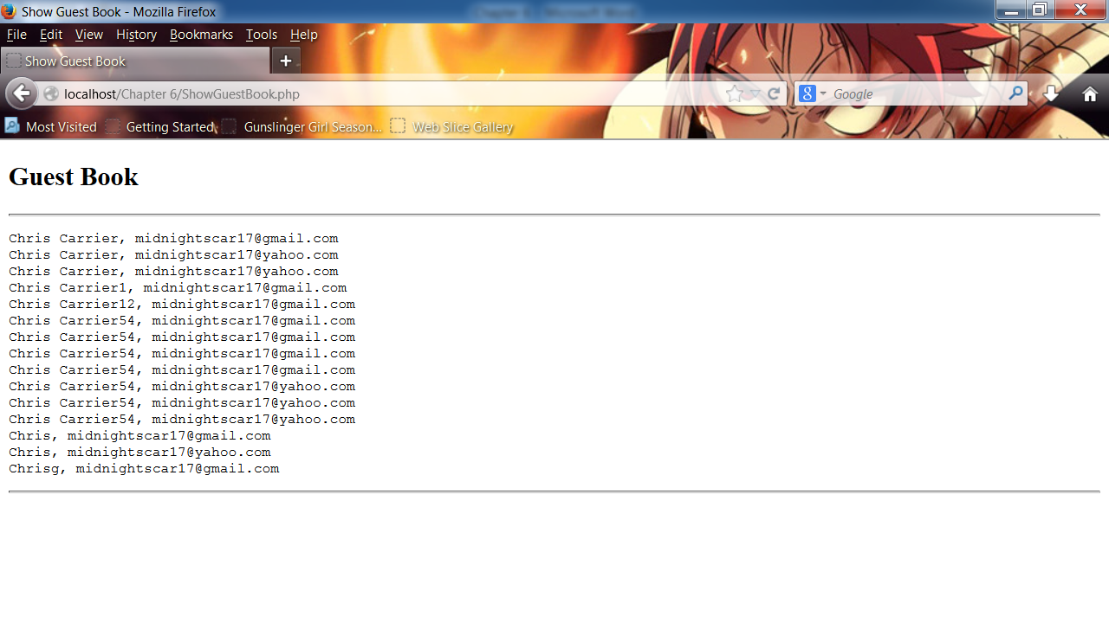

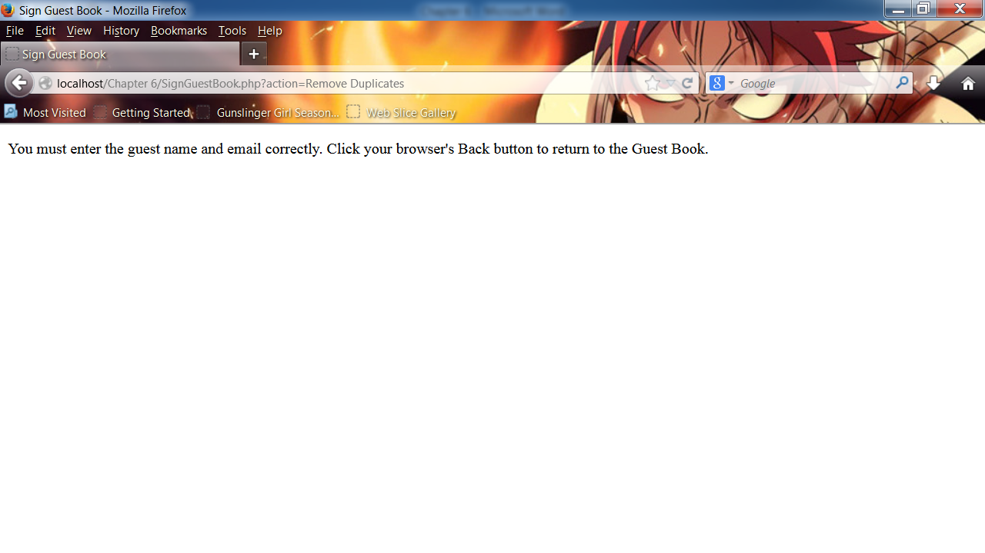

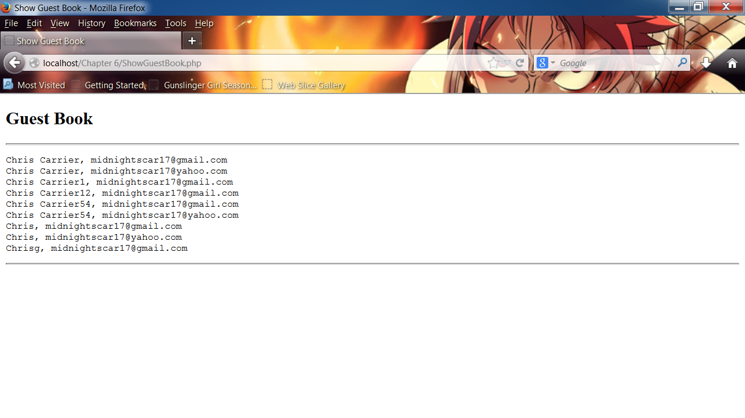

6-5

<!DOCTYPE html PUBLIC "-//W3C//DTD XHTML 1.0 Strict//EN"

"http://www.w3.org/TR/xhtml1/DTD/xhtml1-strict.dtd">

<html xmlns="http://www.w3.org/1999/xhtml">

<head>

<title>Online Order Form</title>

<meta http-equiv="content-type" content="text/html; charset=iso-8859-1" />

</head>

<body>

<h2 style="text-align: center">Order Form</h2>

<form method="post" action="StoreOnlineForm.php">

<p>Name: <input type="text" name='name' required /></p>

<p>Price: $<input type="text" name='price' required /></p>

<p>Description: </p><textarea name='description' rows="6" cols="80"></textarea>

<p><input type="submit" name="Update" value="Update Bug Report" />

<input type="submit" name="Submit" value="Submit Order" /></p>

</form>

<p>

<a href="ShowOrderForm.php">Show Sale Details!</a>

</p>

<?php

?>

</body>

</html>

<!DOCTYPE html PUBLIC "-//W3C//DTD XHTML 1.0 Strict//EN"

"http://www.w3.org/TR/xhtml1/DTD/xhtml1-strict.dtd">

<html xmlns="http://www.w3.org/1999/xhtml">

<head>

<title>Store Online Form</title>

<meta http-equiv="content-type" content="text/html; charset=iso-8859-1" />

</head>

<body>

<?php

$Dir = "OnlineOrders";

if(is_dir($Dir)){

$DirEntries = scandir($Dir, 1);

}

else{

mkdir($Dir);

}

if(empty($_POST['name']) || empty($_POST['price']) || empty($_POST['description'])){

echo "<p>You must enter all the information correctly. Click your browser's Back button

to return to the Online Order Form.</p>\n";

}

else{

$Name = stripslashes($_POST['name']);

$Price = stripslashes($_POST['price']);

$Description = stripslashes($_POST['description']);

function displayError($Price, $errorMsg){

global $errorCount;

echo "Error for \"$Price\": $errorMsg<br />\n";

++$errorCount;

}

$OrderFile = fopen("OnlineOrders/onlineorders.txt", "ab");

if(preg_match("/^[0-9]+$/i", $Price) == 1){

if(is_numeric($Price)){

$Price = number_format($Price, 2);

}

else

{

echo "You must enter a number in the Price slot.";

}

if(is_writeable("OnlineOrders/onlineorders.txt")){

if(fwrite($OrderFile, "Sale Name: " . $Name . "\nPrice: $" . $Price . "\nDescription: " .

$Description . "<br />\n")){

echo "<p>Thank you for your sale!</p>\n";

}

else

echo "<p>Cannot add your sale to the order. Click your browser's Back button

to return to the Online Order Form.</p>\n";

}

else

echo "<p>Cannot write to the file.</p>\n";

fclose($OrderFile);

}

else{

echo "Please enter a number in the Price slot.

Click your browser's Back button to return to the Online Order Form.</p>\n";

}

}

?>

</body>

</html>

<!DOCTYPE html PUBLIC "-//W3C//DTD XHTML 1.0 Strict//EN"

"http://www.w3.org/TR/xhtml1/DTD/xhtml1-strict.dtd">

<html xmlns="http://www.w3.org/1999/xhtml">

<head>

<title>Show Sale Details!</title>

<meta http-equiv="content-type" content="text/html; charset=iso-8859-1" />

</head>

<body>

<?php

echo "<h2>Sale Details!</h2>";

echo "<hr />";

echo "<pre>\n";

readfile("OnlineOrders/onlineorders.txt");

echo "</pre>\n";

echo "<hr />\n";

?>

</body>

</html>

